

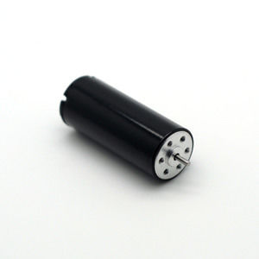

#### 16x40mm Coreless Brushed Series

**SPECIFICATIONS:**

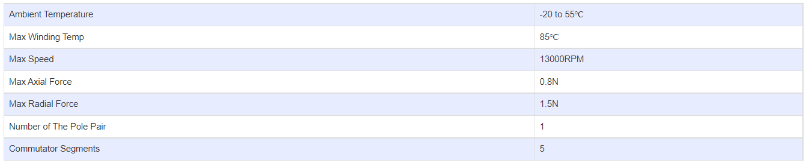

**SUBMODELS:**

*The following are common submodels for the LDO-CL1640 series.*

